Social Media Metrics
The Jump Starter Worksheet

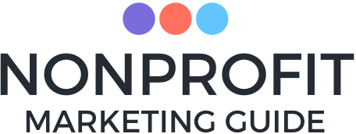

© Nonprofit Marketing Guide. All Rights Reserved.

Our Recommended Approach:
1. What is the point of your social media work, really?
At what level are you good with on-platform engagement alone?
At what level do you need follow-throughs on calls to action, such as clicks off social to your website where another action may occur?
2. Start with what you actually have control over without spending: Topics, Formats, and Frequency and their impact on Reach and Engagement (and Engagement Over Reach)
3. Then expand your organic reach with paid reach once you know what is working.

Social Media Metrics within a Given Time Frame (Last 28 or 90 days?)
*Kivi’s Favorites
Activity (how many posts, what about, what format):
- *Number of Posts - what’s your average frequency (per week or month)?

- *Topics of Posts - what are some easy ways to categorize these?

- *Formats of Posts - more channel-specific, but what are some easy ways to categorize these based on what you typically post? Think of basic ones like links/images/text/videos but also if you have any particular differences within those (e.g. live video versus recorded, certain graphics versus photo images)

Reach (how many saw it, who they are):
- Total Followers (may also note any standouts)

- *New Followers

- *Post Reach (FB: The number of people who saw any post in the given timeframe at least once)

Engagement (what did they do with the content):
Looking at People Overall
- Post Engagement (FB: The number of reactions, shares, comments, clicks in given time period)

- *Engagement / Reach (% of people who saw content that engaged with content)

- Reach / Followers (% of followers that actually saw content - reach can include non-followers)
- Engagement / Followers (% of followers who engaged - engagement can include non-followers)

Looking at Content Specifically (Top 5-10? Depends on where you start to see meaning)
- Top Posts by Reach

- Top Posts by Engagement

- *Top Posts by Engagement / Reach

- *Engagement by Topics or Format of Content

Impact (what is the result):
(Does engagement = impact for you? Is that the point of your social content, or do you have a call to action where you can measure a conversion?)
- Click to a website page?
- Click to another action within the platform itself?
- Completion of an action after the click?

Next step: Take what is meaningful to you here and move it into a spreadsheet or whatever format is easiest for you to track.

